**Assignment 8**

**120100093**

dt = 1 and dy = .01

First Boundary Condition

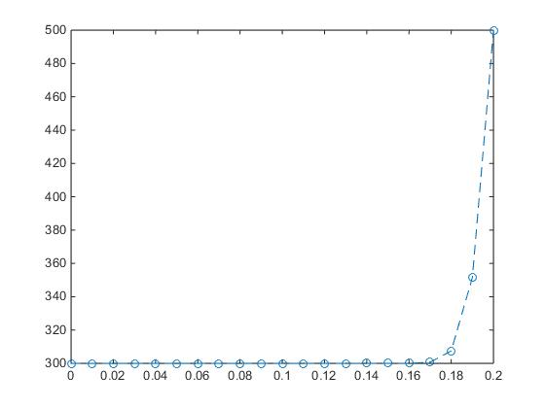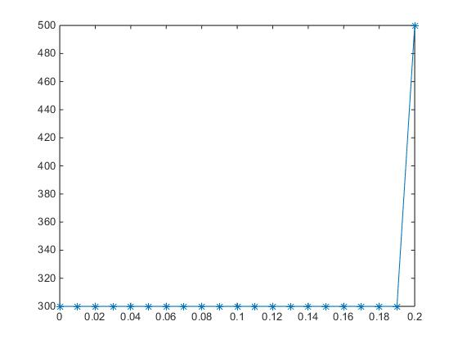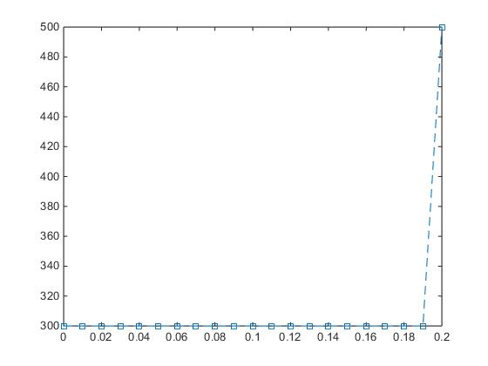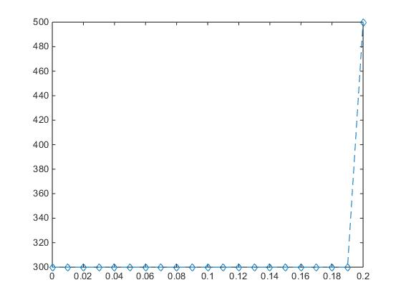

1. FTCS 2)Du Fort Frenkel 3)Implicit Method 4)Crank Nicholson

Second Boundary Condition

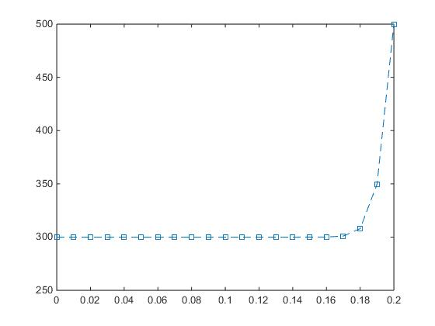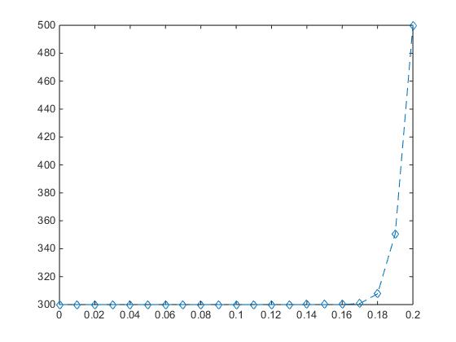

1. FTCS 2)Du Fort Frenkel 3)Implicit Method 4)Crank Nicholson

dt = 0.1 and dy = .01

First Boundary Condition

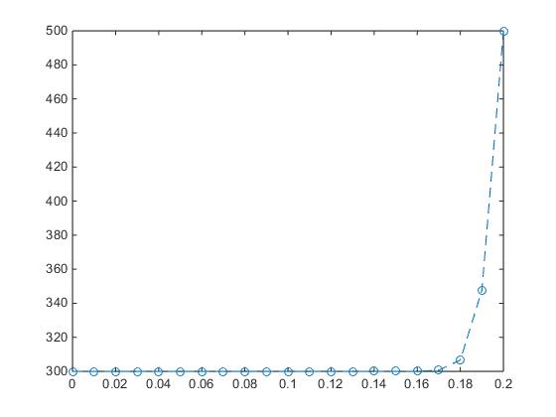

1. FTCS 2)Du Fort Frenkel 3)Implicit Method 4)Crank Nicholson

Second Boundary Condition

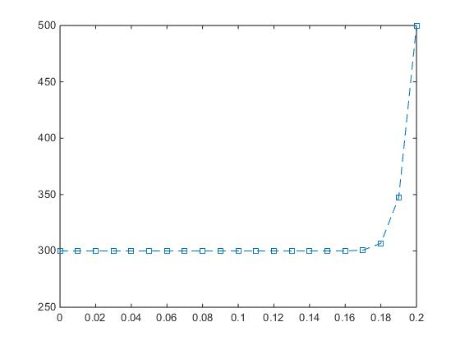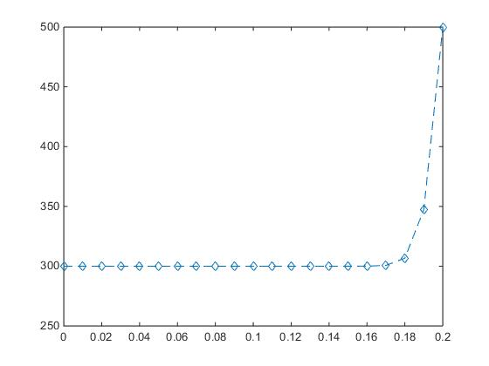

1. FTCS 2)Du Fort Frenkel 3)Implicit Method 4)Crank Nicholson

dt = 0.01 and dy = .01

First Boundary Condition

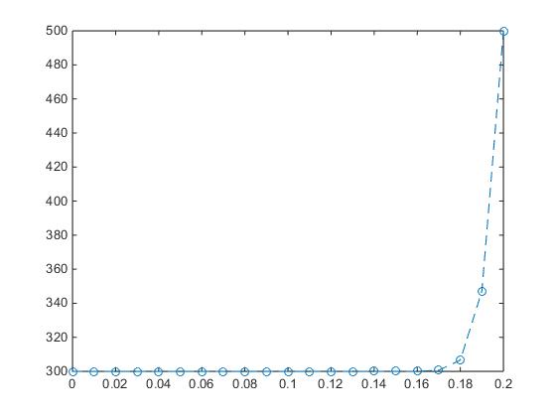

1. FTCS 2)Du Fort Frenkel 3)Implicit Method 4)Crank Nicholson

Second Boundary Condition

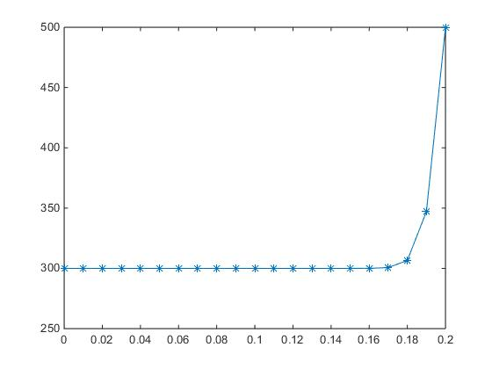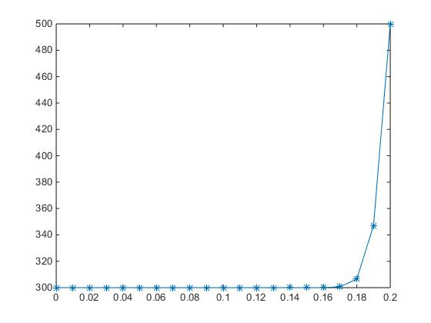

1. FTCS 2)Du Fort Frenkel 3)Implicit Method 4)Crank Nicholson

dt = 0.001 and dy = .01

First Boundary Condition

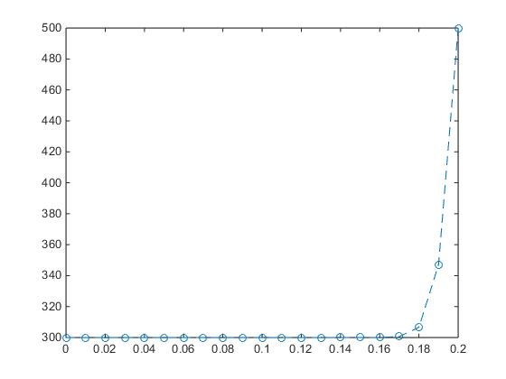

1. FTCS 2)Du Fort Frenkel 3)Implicit Method 4)Crank Nicholson

Second Boundary Condition

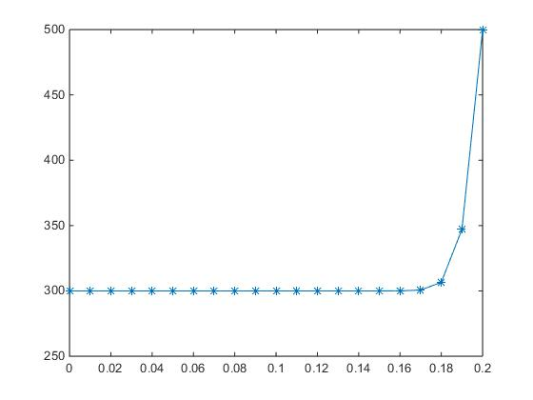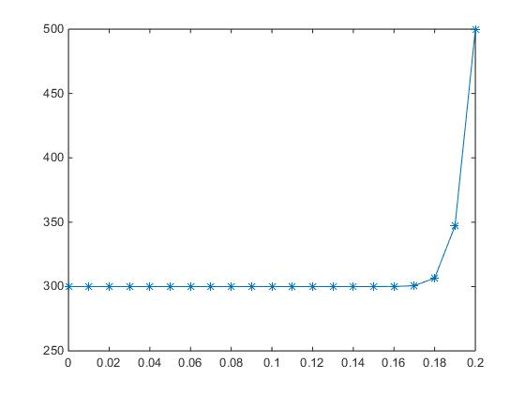

1. FTCS 2)Du Fort Frenkel 3)Implicit Method 4)Crank Nicholson

dt = 1 and dy = .001

First Boundary Condition

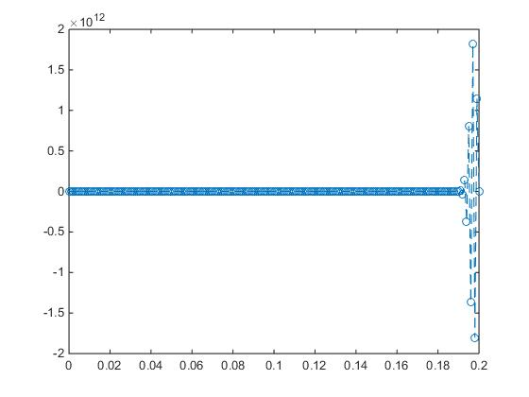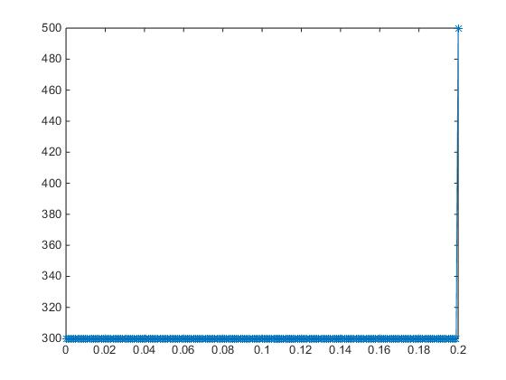

1. FTCS 2)Du Fort Frenkel 3)Implicit Method 4)Crank Nicholson

Second Boundary Condition

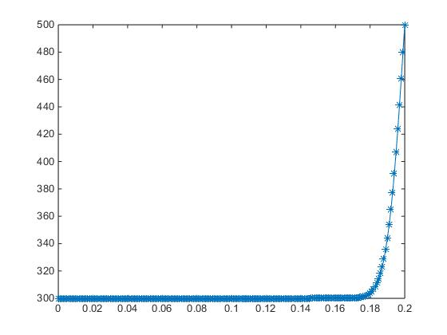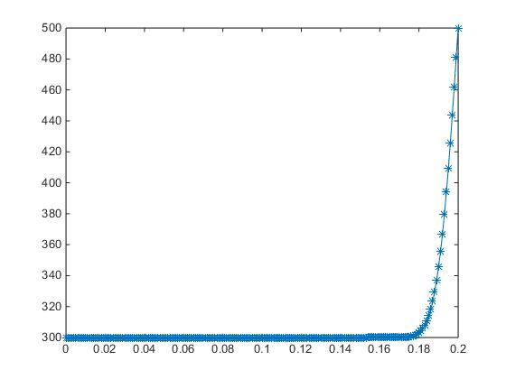

1. FTCS 2)Du Fort Frenkel 3)Implicit Method 4)Crank Nicholson

dt = 0.1 and dy = .001

First Boundary Condition

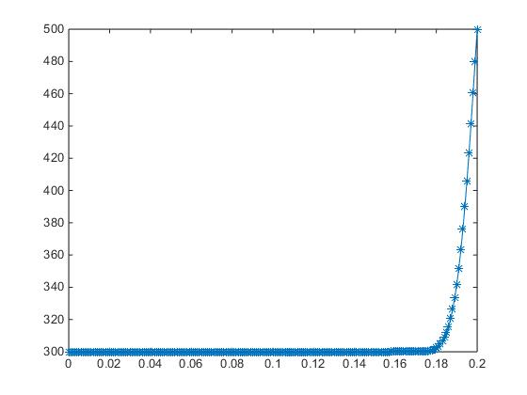

1. FTCS 2)Du Fort Frenkel 3)Implicit Method 4)Crank Nicholson

Second BC

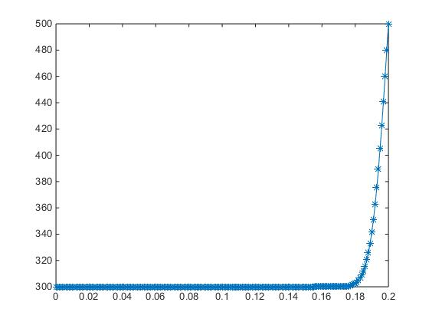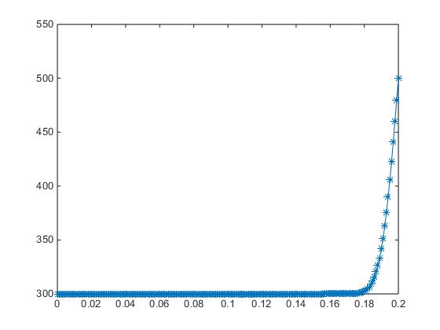

1. FTCS 2)Du Fort Frenkel 3)Implicit Method 4)Crank Nicholson

dt = 0.01 and dy = .001

First Boundary Condition

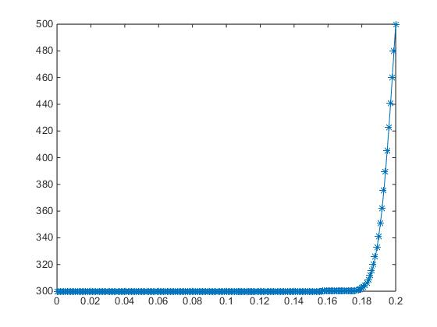

1. FTCS 2)Du Fort Frenkel 3)Implicit Method 4)Crank Nicholson

Second BC

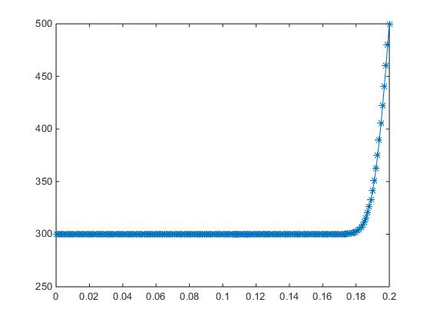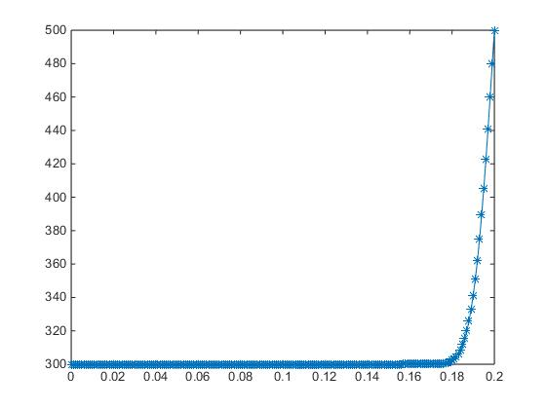

1. FTCS 2)Du Fort Frenkel 3)Implicit Method 4)Crank Nicholson

dt = 0.001 and dy = .001

First Boundary Condition

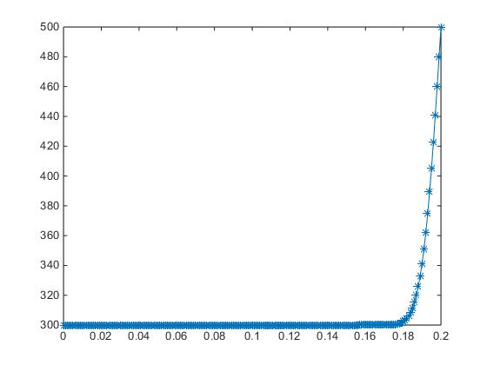

1. FTCS 2)Du Fort Frenkel 3)Implicit Method 4)Crank Nicholson

Second BC

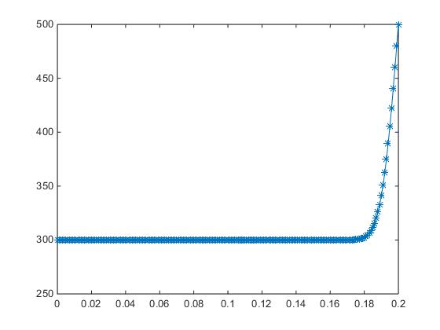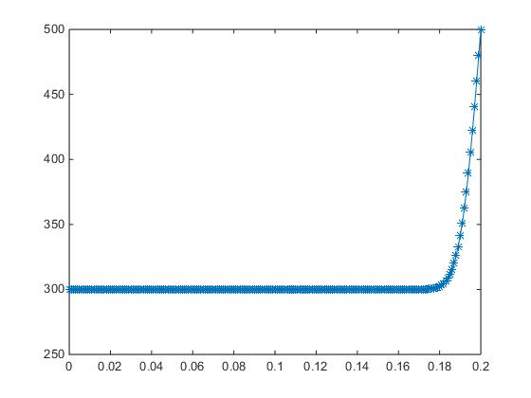

1. FTCS 2)Du Fort Frenkel 3)Implicit Method 4)Crank Nicholson

Conclusions

* All the methods give similar solutions as seen from the graph
* As the value of delta y increases the graph becomes smoother as we are able to capture the gradients in a better manner
* The explicit methods satisfies the stability criterion for all the cases except for the combination delta y = 0.001 and delta t =1

($α∂t/(∂y)^2$) > 0.5 for this case)

* The implicit method and the Crank Nicholson method always gave stable solutions irrespective of values of delta t and delta y